Emergence of Embeddings from BOW to Self Attention:

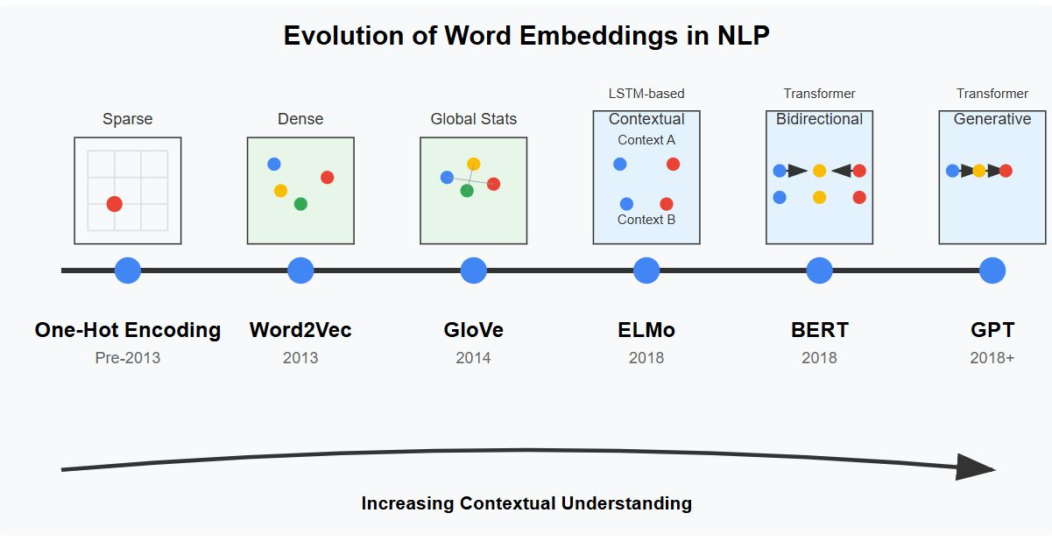

Evolution of Text Representation in numbers:
- Bag of Words (BoW) (1990s–early 2000s)
- Idea: Represent a document by just counting how many times each word appears.
- Example:
Sentence: “The cat sat on the mat”
BoW: {the:2, cat:1, sat:1, on:1, mat:1}
- Pros: Simple, works okay for small tasks.
- Cons:
  - Ignores word order (“cat sat” = “sat cat”).
  - Leads to huge sparse vectors (one dimension per word in dictionary).

- TF-IDF (Term Frequency – Inverse Document Frequency) (2000s)
- Idea: Improve BoW by reducing importance of common words (like “the,” “is”).
- Formula downweights frequent words across all docs, highlights rare but important ones.
- Example:
  - Word “the” gets low weight.
  - Word “volcano” gets high weight.
  - Cons: Still ignores order & meaning.

- Word Embeddings (Word2Vec, GloVe, FastText) (2013–2017)
- Idea: Map each word to a dense vector (like 100–300 numbers).
- Words that appear in similar contexts → close in vector space.
- Example:
  - king – man + woman = queen
  - Pros: Captures meaning, relationships.
  - Cons:
  - Static (one vector per word).
  - Fails for multiple meanings (bank = river/money).
  - OOV problem for unseen words (Word2Vec/GloVe).

- Contextual Embeddings (ELMo, BERT, GPT, Transformer-based) (2018–present)
- Idea: A word’s vector depends on the sentence it appears in.
- Example:
  - “He sat by the river bank.” → “bank” ≠ “She deposited money in the bank.”
  - Achieved using Transformers + Attention.
- Pros:
  - Handles multiple meanings (polysemy).
  - Captures grammar, syntax, long dependencies.
  - Foundation for state-of-the-art NLP (ChatGPT, Google Translate, etc.).

Note:
1. We evolved from counting words (BoW) → to weighing words (TF-IDF) → to static vectors (Word2Vec/GloVe) → to dynamic, context-aware vectors (BERT/GPT) that power today’s NLP.
2. The problem of average meaning = static embeddings give each word only one vector, forcing all its meanings into a single “average” — which modern contextual embeddings (BERT/GPT) overcome.

- Difference between Word Embeddings (Static Embeddings) and Contextual Embeddings (Dynamic Embeddings)

Word Embeddings (Static Embeddings):

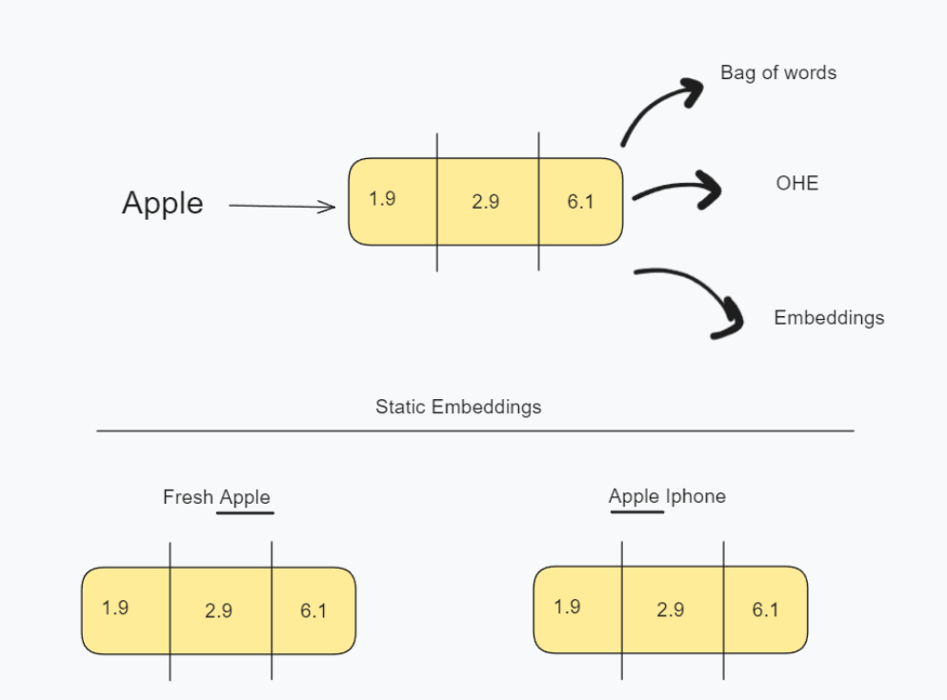

Algorithms like Word2Vec, GloVe, FastText create a single vector for each word in the vocabulary.
That vector is the same no matter where the word appears.

Contextual Embeddings (Dynamic Embeddings):

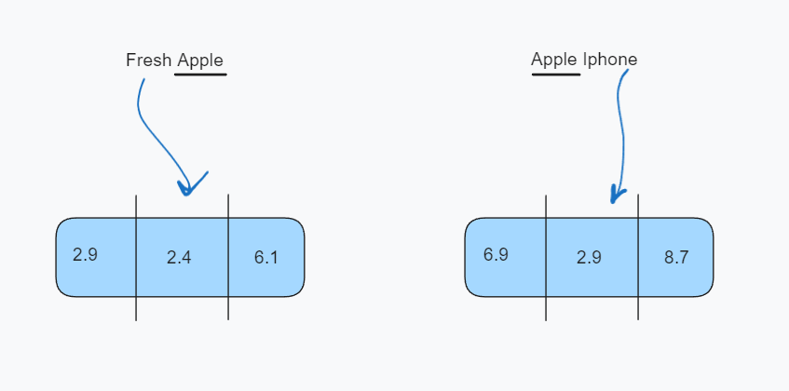

Models like ELMo, BERT, GPT assign a different vector to the same word depending on the sentence context.
Built using Transformers + Attention Mechanism.
Example:
Word: "bank"
Sentence 1: “He went to the bank to withdraw money.” → vector.
Sentence 2: “She sat by the bank of the river.” → vector.
Now, two different embeddings for the same word!

Advantages:
- Solves polysemy: multiple meanings correctly represented.
- Captures grammar & syntax:
  - “dog bites man” ≠ “man bites dog.”
- Handles new/rare words:
  - Breaks words into sub-parts (Covid → Co + vid).

Real-World Scenarios
- Search Engines
  - Word2Vec: Searching “Apple” → mixes fruit and company
  - BERT: Can rank results properly depending on query context.

- Voice Assistants
  - Word2Vec: Misunderstands “Play cold play” (band) vs “play in cold” (weather).
  - GPT: Understands the context → plays Coldplay songs.
- Translation
  - Word2Vec: “Crane” → confused between bird and machine
  - BERT: Correctly picks sense from sentence context.

Summary:
Word Embeddings = Dictionary-style → one word, one meaning.
Contextual Embeddings = Human-style → word meaning changes depending on the sentence.

Self Attention (Converts Static Embeddings into Dynamic Contextual Embeddings):
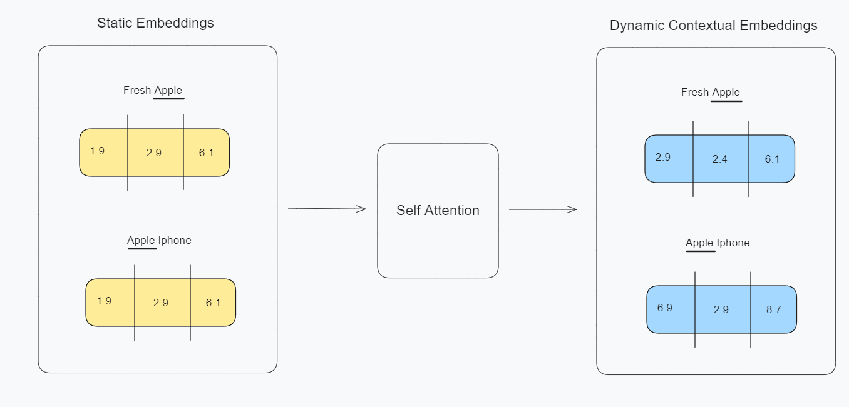

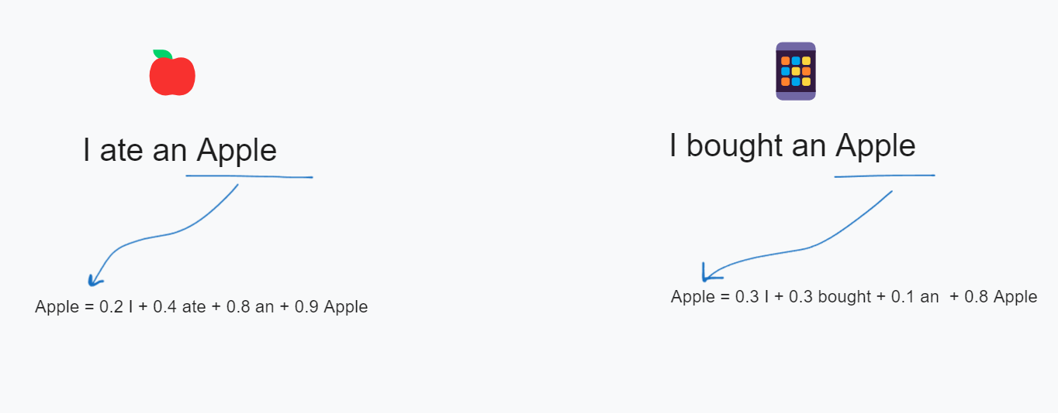

The image demonstrates how the meaning of the word "Apple" changes depending on its context in a sentence. This is achieved through contextual embeddings, where the representation of a word adapts based on the surrounding words. Let’s break down the example.

